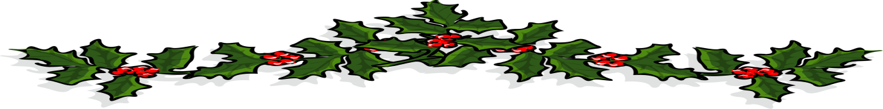
Lythe Brow Alpacas
Adopt an Alpaca
Looking for an alternative Christmas Gift?
Your adoption money will go towards looking after the Alpaca you have chosen, feeding, vaccinations, hay and injections and anything else they may need throughout the year.

Package one:
- Adoption certificate including your personalised message valid for 12 months
- Photograph sent to email or address
- Fact sheet about Alpacas
- Profile about your chosen Alpaca
- Sample of your chosen Alpaca’s fleece
- Quarterly email updates about what your chosen Alpaca has been up to, including pictures
Price £24 payable by paypal to lythebrowalpacas@yahoo.com or via bank transfer

Package Two:
- Adoption certificate including your personalised message valid for 12 months
- Photograph sent to email or address
- Fact sheet about Alpacas
- Profile about your chosen Alpaca
- Sample of your chosen Alpaca’s fleece
- Quarterly email updates about what your chosen Alpaca has been up to, including pictures
- Plus ……An invitation to come and meet your chosen Alpaca at Lythe Brow Farm in Lancaster twice throughout the 12 month period (by prior arrangement) to see for yourself how they are growing and developing and you will get to meet the rest of the herd.
Price £42 payable by paypal to lythebrowalpacas@yahoo.com or via bank transfer
